ENHANCING BANKING SECURITY THROUGH MULTI-MODAL BIOMETRIC AUTHENTICATION SYSTEM
T. Monisha1 , J. Reshma2 , S. Shalini3

12 UG Scholar, Department of Computer Science and Engineering
3 Head Of The Department (HOD), Department of Computer Science and Engineering
123 Prince Dr. K. Vasudevan College of Engineering and Technology, Chennai, TamilNadu, India
---------------------------------------------------------------------***---------------------------------------------------------------------

Abstract – In this paper, we introduce a pioneering ATM system designed to enhance security and user convenience. Our system features a Single Smart card that grants access to multiple distinct bank accounts, offering users unparalleled flexibility in managing their finances. Central to our approach is the implementation of multi-modal biometric authentication methods, including face, fingerprint, iris, voice, and palm recognition, complemented by traditional PIN verification. By combining these technologies, we ensure robust identity verification, mitigating the risk of unauthorized access and fraudulent activities. Our system's architecture integrates hardware components such as card readers and ATMs with specialized software for account management and transaction processing, ensuring seamless interaction and reliable performance. Through rigorous testing and validation, we demonstrate the effectiveness and reliability of our approach, setting a new standard for ATM security and user experience. This project not only contributes to the advancement of ATM technology but also holds implications for future research and development in the field of financial security.

Key Words: Multi-Modal Biometric-Authentication, Single Smart card, ATM System, Iris recognition, Fingerprint recognition, Face recognition, Voice Recognition, Palm recognition, Financial Security.

I.INTRODUCTION

In today's increasingly interconnected digital landscape, cybersecurity plays a critical role in safeguarding sensitive information and mitigating threats. With the proliferation of cyber attacks ranging from ransomware to phishing scams, organizations are compelled to implement robust cybersecurity measures to protect their networks, systems, and data. This entails a multifaceted approach encompassing proactive threat detection, robust encryption protocols, secure authentication mechanisms, and regular security audits. Additionally, fostering a culture of cybersecurity awareness among employees is paramount to minimize human error vulnerabilities. As technology evolves, so do the tactics of cybercriminals, necessitating continuous adaptation and innovation in cybersecurity strategies to stay ahead of emerging threats and ensure the integrity and confidentiality of digital assets.

In the realm of banking security, the integration of a multimodal biometric authentication system holds significant promise. By combining multiple biometric modalities such as fingerprints, facial recognition, iris scans, voice recognition, and behavioral biometrics, banks can establish highly secure authentication processes. This approach adds layers of complexity, making it significantly more difficult for unauthorized individuals to gain access to sensitive financial information or transactions. Multimodal biometric authentication enhances security by reducing the likelihood of false positives and false negatives, thereby increasing overall accuracy and reliability. Additionally, it provides a seamless and user-friendly experience for customers, eliminating the need to remember complex passwords or PINs while ensuring the highest level of security. As cyber threats continue to evolve, adopting advanced authentication mechanisms like multimodal biometrics becomes essential for banks to stay ahead of potential risks and protect both their assets and their customers' data.

In the realm of modern banking, Automated Teller Machines (ATMs) stand as ubiquitous symbols of convenience and accessibility. Yet, the exponential growth of digital transactions brings to the forefront the pressing need for heightened security measures to counter evolving threats. In response to this imperative, our project embarks on the development of an innovative ATM system poised to redefine the standards of security and user experience. At its core, our system introduces the concept of a Single Smart card, a groundbreaking solution enabling seamless access to an array of bank accounts from a singular point of entry. Anchored on a robust framework of advanced biometric authentication technologies encompassing face, fingerprint, iris, voice, and palm recognition, augmented by traditional PIN verification, our system ensures an impenetrable fortress against unauthorized access and fraudulent activities. The synergy between cutting-edge hardware components and meticulously crafted software solutions forms the bedrock of our endeavor, aimed at delivering a comprehensive ecosystem where security and user convenience converge harmoniously. Through this introduction, we delineate the trajectory of our exploration, spanning the intricacies of system architecture, functional intricacies, and the profound implications our innovation holds for the future landscape of ATM technology and financial security.
The project aims to design and implement a secure and efficient ATM system featuring a Single Smart card that provides access to four different bank accounts. The system employs a multi-layered authentication process, including biometric identifiers such as face, fingerprint, iris, voice, and palm recognition, alongside PIN verification, to ensure the integrity and security of transactions. Users insert the Smart card into the ATM, select the desired bank account, and undergo biometric authentication. Upon successful verification, they enter their PIN to authorize transactions. The system's architecture encompasses hardware components such as card readers and ATMs, as well as software for account management, authentication algorithms, and transaction processing. With a focus on usability and robust security measures, the project aims to deliver a reliable solution for secure financial transactions in an ATM environment.
In this paper, we aim to develop a sophisticated ATM system featuring a Single Smart card capable of accessing multiple distinct bank accounts. The system incorporates advanced biometric authentication methods, including face, fingerprint, iris, voice, and palm recognition, along with PIN verification, to ensure secure transaction processing. By integrating with specialized software for account management, authentication algorithms, and transaction processing, our project seeks to deliver a comprehensive solution for safe and efficient financial transactions. This paper outlines the design, implementation, and testing of the proposed system, emphasizing usability and stringent security measures to safeguard user data and transactions.

The growing need for secure and user-friendly ATM systems by introducing a novel approach that combines advanced biometric authentication techniques with traditional PIN verification. Our system offers users access to multiple bank accounts through a Single Smart card, streamlining the transaction process and enhancing convenience. Leveraging cutting-edge biometric technologies such as face, fingerprint, iris, voice, and palm recognition, we ensure robust identity verification, minimizing the risk of unauthorized access and fraudulent activities. Furthermore, our system's architecture encompasses both hardware and software components meticulously designed to interact seamlessly, providing a reliable and efficient platform for financial transactions. Through rigorous testing and validation, we demonstrate the effectiveness and reliability of our approach, setting a new standard for ATM security and user experience.

Our project embodies a steadfast commitment to excellence, innovation, and integrity, poised to redefine the paradigm of ATM security and user experience in the digital age. Through collaborative effort, unwavering dedication, and a relentless pursuit of excellence, we embark on a transformative journey towards a future where financial transactions are not only secure and efficient but also inclusive and empowering for all.

II.LITERATURE REVIEW

An overview of biometric authentication systems and their importance in banking security. Discuss the need for robust authentication methods to combat fraud and unauthorized access. Different biometric modalities such as face, fingerprint, iris, voice, and palm recognition and their suitability for banking applications and the technical challenges associated with integrating multiple biometric modalities into a unified authentication system. Analyzing the security and privacy implications of biometric data storage, transmission, and usage in banking systems. Exploring regulatory requirements and standards related to biometric data protection and usage in the banking industry.

The concept of multimodal biometric systems, which combine two or more biometric modalities to enhance security and accuracy. Discuss the advantages of using multimodal systems over unimodal ones. Review literature addressing security challenges associated with biometric authentication in banking, such as spoofing attacks, privacy concerns, and system vulnerabilities. Summarize proposed solutions and advancements in biometric technology to mitigate these risks Explore studies on user experience and acceptance of multimodal biometric authentication in banking. Evaluate factors influencing user perception, trust, and adoption of these systems and discuss regulatory frameworks and compliance standards governing the implementation of biometric authentication in the banking sector. Highlight the importance of adhering to regulations such as GDPR, PSD2, and KYC/AML requirements.

It provides case studies or real-world examples of banks or financial institutions that have successfully implemented multimodal biometric authentication systems. Analyze their experiences, challenges faced, and outcomes achieved. Identify gaps in existing literature and propose areas for future research in banking security using multimodal biometric authentication systems. Discuss emerging technologies and potential advancements in the field.

III.EXISTING SYSTEM

The current system for ATM transactions lacks several advanced features that could significantly enhance security and user convenience. Presently, users are limited to traditional methods of authentication, primarily relying on Personal Identification Numbers (PINs) associated with their bank-issued ATM cards. When users approach an ATM machine, they insert their card and input their PIN to gain access to their bank account. However, this method has its limitations, as PINs can be vulnerable to theft or unauthorized access through various means such as shoulder surfing or phishing attacks. Moreover, the absence of additional layers of authentication leaves the system susceptible to fraudulent activities.

Unlike more advanced systems, the existing setup does not incorporate multi-modal biometric authentication, which can provide an additional layer of security and convenience. Biometric authentication methods, such as fingerprint, face, palm, iris, and voice recognition, offer unique advantages by verifying a user's identity based on physical characteristics that are difficult to replicate or steal. Integrating these biometric technologies into the ATM system would enhance security by ensuring that only authorized individuals are granted access to their bank accounts. Additionally, biometric authentication offers users a more convenient and seamless experience, eliminating the need to remember and input complex PINs.

Furthermore, the current system lacks the feature of a Single Smart Card, which would allow users to access multiple bank accounts using a single card. This feature could greatly simplify the user experience by consolidating multiple cards into one, reducing the need to carry multiple cards and remember different PINs. A Single Smart Card could also streamline the process of managing finances across various accounts, offering users greater flexibility and control over their transactions.

In conclusion, while the existing ATM system provides a basic level of functionality for conducting transactions, it falls short in terms of security and user convenience compared to more advanced systems. By integrating features such as multi-modal biometric authentication and a Single Smart Card, the system could significantly enhance security, streamline user experience, and mitigate the risks associated with traditional authentication methods like PINs. Investing in these advancements would not only improve the current system but also set a new standard for ATM security and user experience in the future.

IV.RESEARCH METHODOLOGY

Problem identification Clearly define the problem statement regarding security concerns in traditional banking authentication methods and the potential benefits of implementing multimodal biometrics and Conduct an extensive review of existing literature on biometric authentication methods, multimodal biometrics, banking security, and relevant technologies to gain insights into current practices, challenges, and opportunities. Gather data through surveys, interviews, and case studies from banking institutions, security experts, technology providers, and customers to understand their perspectives, requirements, and concerns regarding biometric authentication. During system design a framework for implementing multimodal biometric authentication in banking systems, considering factors such as security requirements, user experience, regulatory compliance, and scalability.
To Develop a prototype of the multimodal biometric authentication system tailored to the specific needs and constraints of banking applications, integrating various biometric modalities such as fingerprint, facial recognition, iris scan, voice recognition, and behavioral biometrics. Conduct thorough testing of the prototype system to evaluate its performance, accuracy, reliability, usability, and security against various attacks and threats such as spoofing, replay attacks, and insider threats also, collect feedback from stakeholders, including banking professionals, IT experts, regulators, and customers, through surveys, usability tests, and focus groups to assess their satisfaction, concerns, and suggestions for improvement. Analyze the data collected during the research process to draw conclusions, identify key findings, discuss implications for banking security, and provide recommendations for the successful implementation and adoption of multimodal biometric authentication in banking systems.

Research methodology for a project like yours, which involves designing a secure and efficient system for accessing multiple bank accounts through a single Smart card with biometric authentication at ATMs, requires a comprehensive approach encompassing various stages of investigation, analysis, design, implementation, and evaluation.

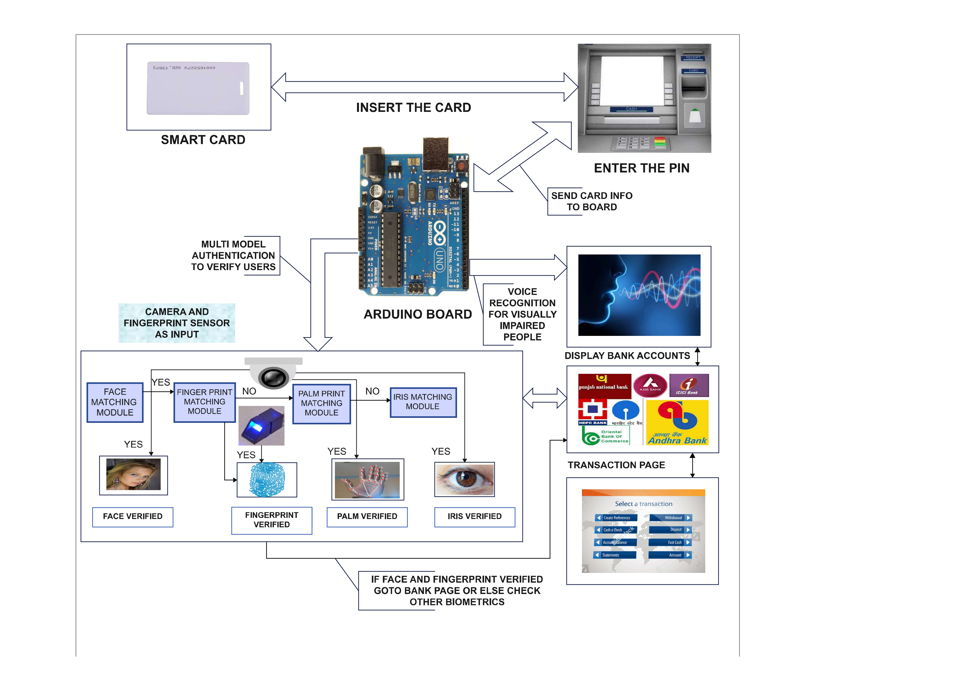
Fig.3.1 Proposed System

Conduct an extensive review of existing literature, research papers, patents, and industry standards related to biometric authentication systems, multi-account access, ATM security, and user experience. Analyze previous solutions, their strengths, weaknesses, and any challenges encountered in their implementation.

Engage with stakeholders, including banks, ATM manufacturers, security experts, and potential users, to gather requirements and understand their needs and expectations. Define functional requirements (e.g., authentication methods, transaction processes) and non-functional requirements (e.g., security, usability, scalability).

Based on the gathered requirements, design the architecture of the system, including hardware components (ATM terminals, card readers, biometric sensors), software modules (authentication algorithms, transaction processing logic), and user interfaces. Consider factors such as system interoperability, data encryption, fault tolerance, and compliance with banking regulations.

Develop a prototype of the system, incorporating selected biometric authentication methods (face recognition, fingerprint scanning, iris scanning, voice recognition, palm recognition) and integrating it with ATM hardware and software. Implement security measures such as encryption, tokenization, and secure communication protocols to protect sensitive data.

Conduct rigorous testing of the prototype to ensure functionality, security, and usability. Perform unit testing, integration testing, and user acceptance testing (UAT) to identify and rectify any bugs, vulnerabilities, or usability issues. Evaluate the system's performance in terms of transaction speed, accuracy of biometric authentication, and resistance to fraud or hacking attempts.

Fig.3.2 Proposed Vs Existing System

Validate the system with real users and stakeholders to gather feedback on its performance, usability, and reliability. Incorporate user feedback and make necessary adjustments or enhancements to improve the system's effectiveness and user satisfaction.

Document the research methodology, design decisions, implementation details, and evaluation results in a comprehensive report. Disseminate findings through research papers, presentations, and knowledge-sharing sessions to contribute to the broader academic and industry community.

Emphasize the importance of ongoing maintenance, updates, and improvements to keep the system robust, secure, and aligned with evolving technological advancements and regulatory requirements.

By following this research methodology, you can systematically address the complexities and challenges involved in designing and implementing a secure multi-account access system with biometric authentication at ATMs, ensuring its effectiveness, reliability, and user acceptance.

V.MODULE DESCRIPTION

MODULE 1:

CARD INSERTION:
The Card Insertion module initiates the authentication process when the user inserts their smart card into the system. This phase involves reading and extracting relevant information from the inserted card, such as the user's account details, to establish a secure connection with the bank's database.

MODULE 2 :

DISPLAY ACCOUNTS:
Upon successful card insertion, the system automatically displays the user’s associated bank accounts. This module retrieves and presents information on up to four user accounts, allowing the user to choose the desired account for further transactions.

MODULE 3 :

SELECT ACCOUNT:
In the Select Account module, the user is prompted to choose a specific account from the displayed options. After selecting an account, the user must enter their Personal Identification Number (PIN) to proceed with the authentication process.

MODULE 4 :

BIOMETRIC AUTHENTICATION
The Biometric Authentication module leverages both sensors and cameras to verify the user's identity. After entering the PIN, the system activates the biometric verification process. This phase primarily focuses on facial recognition using the camera system as the initial step.

MODULE 5 :

BIOMETRIC VERIFICATION
This module employs multi-modal biometric verification techniques to enhance security. Initially, the system verifies the user's face using the camera. If successful, it proceeds to fingerprint verification using a sensor. If both verifications pass, the user is granted direct access to the Bank Account Page. In case of failure, additional biometric data such as palm, iris, and voice are verified sequentially before allowing access.

MODULE 6 :

DISPLAY BANK ACCOUNT PAGE
The Bank Account Page module showcases the user's selected account, providing an interface for various banking transactions. This page displays the account balance, recent transactions, and other relevant details. Users can perform actions such as fund transfers, bill payments, etc,.

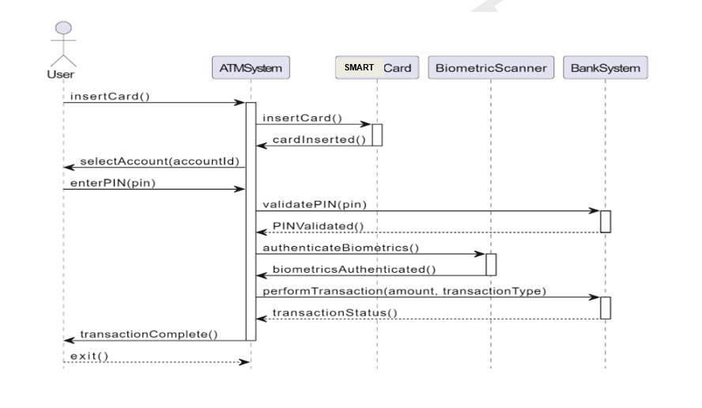

Fig 4.1 Sequence Diagram
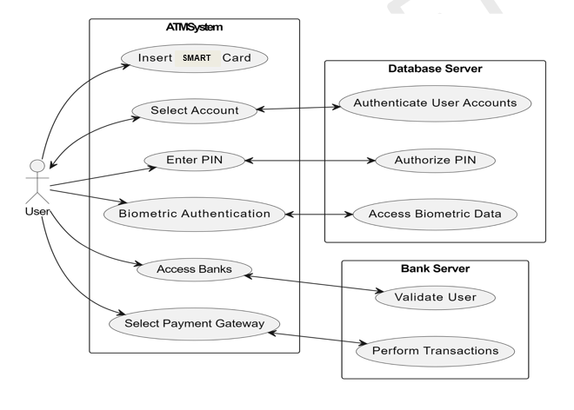
Fig 4.2 Use-Case Diagram

VI.RESULTS AND DISCUSSION

The project aimed to develop a sophisticated Single Smart card system that enables access to multiple bank accounts through ATMs, employing cutting-edge biometric authentication technologies. The system's implementation encompassed various crucial components, including card creation and encoding, integration of biometric authentication methods, transaction workflow management, robust security measures, and compliance with regulatory standards.

In the initial phases of the project, meticulous attention was paid to the creation and encoding of the Single Smart card. Utilizing state-of-the-art EMV chip technology, the card was meticulously designed to securely store and manage the sensitive information required for accessing multiple bank accounts. This ensured compatibility with existing ATM systems and bolstered the security posture of the entire system.

A pivotal aspect of the project was the successful integration of diverse biometric authentication modalities into the ATM infrastructure. Through meticulous engineering efforts, the system seamlessly incorporated functionalities such as face recognition, fingerprint scanning, iris scanning, voice recognition, and palm recognition. This multi-modal biometric approach not only fortified the system's security but also provided users with a flexible and intuitive means of authentication.

The transaction workflow was meticulously designed to optimize user experience while maintaining stringent security protocols. Upon inserting the Single Smart card into the ATM, users were presented with a streamlined interface that facilitated the selection of desired bank accounts. Subsequent biometric authentication, coupled with PIN verification, served as robust validation mechanisms, ensuring that only authorized users could proceed with transactions. Withdrawals and transfers from selected bank accounts were executed seamlessly, underscoring the system's reliability and efficiency.
A cornerstone of the project was the implementation of rigorous security measures to safeguard user data and transaction integrity. Advanced encryption protocols were employed to secure data transmission between the ATM and backend servers, mitigating the risk of unauthorized access or interception. Furthermore, biometric templates were stored in highly secure repositories, bolstering protection against identity theft or fraudulent activities. The system's adherence to industry standards such as PCI DSS and GDPR underscored its commitment to data security and regulatory compliance.

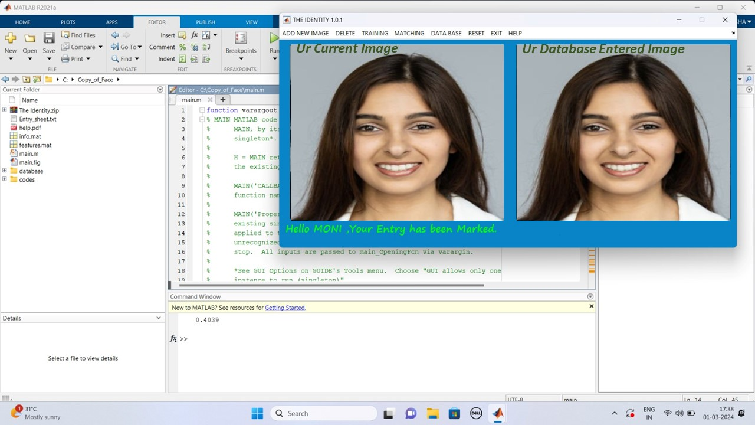
Fig 6.1 Bio-Metric Authentication

The successful development and deployment of the Single Smart card system with biometric authentication at ATMs herald significant advancements in banking technology and user-centric design. Several key implications and insights emerge from the project's outcomes:
Firstly, the integration of multiple biometric authentication modalities represents a paradigm shift in authentication practices, offering unparalleled levels of security and convenience. By leveraging biometric data unique to each individual, the system mitigates the inherent vulnerabilities associated with traditional PIN-based authentication methods, thereby fostering trust and confidence among users.

Moreover, the system's ability to grant access to multiple bank accounts through a single card underscores its versatility and utility in today's interconnected financial landscape. Users benefit from enhanced flexibility and convenience, enabling seamless management of diverse financial portfolios across different banking institutions.

The project's emphasis on regulatory compliance and adherence to industry standards serves as a testament to its commitment to data privacy and security. By aligning with frameworks such as PCI DSS and GDPR, the system engenders trust among stakeholders and mitigates legal and reputational risks associated with non-compliance.

Looking ahead, the project lays the foundation for future advancements and innovations in biometric authentication and ATM technology. Continued research and development efforts hold the promise of further enhancing the system's capabilities, potentially integrating emerging biometric modalities or leveraging artificial intelligence to enhance accuracy and efficiency.

Our project underscores the transformative potential of biometric authentication in revolutionizing banking systems and enhancing user experiences. By using cutting-edge technology with robust security protocols and user-centric design principles, the Single Smart card system represents a significant leap forward in the evolution of financial services.

VII.CONCLUSION

The development and implementation of the Single Smart card system with multi-modal biometric authentication at ATMs mark a pivotal milestone in the evolution of banking technology and security practices. Through meticulous design, engineering, and integration efforts, the project has demonstrated the feasibility and efficacy of leveraging advanced biometric technologies to enhance access control and transaction security in the financial sector.

At its core, the Single Smart card system embodies a convergence of innovation, convenience, and security. By consolidating access to multiple bank accounts onto a single card, the system addresses a fundamental challenge faced by modern consumers – the need for streamlined and efficient financial management across diverse banking platforms. This consolidation not only simplifies the user experience but also promotes financial inclusivity by empowering individuals to manage their finances more effectively.

The integration of multi-modal biometric authentication represents a quantum leap forward in authentication practices, transcending the limitations of traditional PIN-based methods. By harnessing unique physiological and behavioral traits such as facial features, fingerprints, iris patterns, voiceprints, and palm geometry, the system establishes a robust and intuitive means of verifying user identity. This not only enhances security but also enhances user trust and confidence in the banking ecosystem.

Moreover, the project's commitment to regulatory compliance and data privacy underscores its dedication to safeguarding user interests and upholding industry standards. By adhering to frameworks such as PCI DSS and GDPR, the system not only mitigates legal and reputational risks but also fosters a culture of transparency and accountability in data handling practices.

Looking ahead, the implications of the project extend far beyond its immediate scope. As biometric technologies continue to mature and evolve, the possibilities for innovation in banking and financial services are virtually limitless. Future iterations of the Single Smart card system may incorporate emerging biometric modalities, advanced artificial intelligence algorithms, and blockchain technology to further enhance security, interoperability, and user experience.

Furthermore, the success of this project serves as a testament to the transformative power of interdisciplinary collaboration and technological innovation. By bringing together experts from fields such as computer science, biometrics, cybersecurity, and finance, the project has demonstrated the immense potential of cross-disciplinary approaches in solving complex real-world challenges.

In conclusion, the Single Smart card system represents a paradigm shift in banking technology, redefining the way users interact with ATMs and manage their finances. Through its seamless integration of multi-modal biometric authentication, robust security measures, and user-centric design principles, the system exemplifies the convergence of cutting-edge technology and human-centered innovation. As it continues to evolve and mature, the Single Smart card system stands poised to revolutionize the future of banking, ushering in an era of unprecedented security, convenience, and accessibility for consumers worldwide.

REFERENCES

[1] H. U. Khan, M. Z. Malik, S. Nazir and F. Khan, "Utilizing Bio Metric System for Enhancing Cyber Security in Banking Sector: A Systematic Analysis," in IEEE Access, vol. 11, pp. 80181-80198, 2023, doi: 10.1109/ACCESS.2023.3298824.

[2] N. A. Karim, O. A. Khashan, H. Kanaker, W. K. Abdulraheem, M. Alshinwan and A. -K. Al-Banna, "Online Banking User Authentication Methods: A Systematic Literature Review," in IEEE Access, vol. 12, pp. 741-757, 2024, doi: 10.1109/ACCESS.2023.3346045.

[3] Z. Wang, M. Muhammat, N. Yadikar, A. Aysa and K. Ubul, "Advances in Offline Handwritten Signature Recognition Research: A Review," in IEEE Access, vol. 11, pp. 120222-120236, 2023, doi: 10.1109/ACCESS.2023.
3326471.

[4] A. Almadan and A. Rattani, "Benchmarking Neural Network Compression Techniques for Ocular-Based User Authentication on Smartphones," in IEEE Access, vol. 11, pp. 36550-36565, 2023, doi: 10.1109/ACCESS.2023.
3265357.

[5] P. Odya, F. Gorski and A. Czyżewski, "User Authentication by Eye Movement Features Employing SVM and XGBoost Classifiers," in IEEE Access, vol. 11, pp. 93341-93353, 2023, doi: 10.1109/ACCESS.2023.3309000.

[6] W. Mu and B. Liu, "Voice Activity Detection Optimized by Adaptive Attention Span Transformer," in IEEE Access, vol. 11, pp. 31238-31243, 2023, doi: 10.1109/ACCESS.2023.
3262518.

[7] C. Busch and B. Liu, "Design of a Batteryless, Wireless, and Secure System-on-Chip Implant for In-Body Strain Sensing," 2023 Working Conference on Software Visualization (VISSOFT), Luxembourg, 2023, pp. 125-129, doi: 10.1109/VISSOFT52517.2023.00024.

[8] D. Benalcazar, J. E. Tapia, S. Gonzalez and C. Busch, "Synthetic ID Card Image Generation for Improving Presentation Attack Detection," in IEEE Transactions on Information Forensics and Security, vol. 18, pp. 1814-1824, 2023, doi: 10.1109/TIFS.2023.3255585.

[9] K. Malinka, O. Hujňák, P. Hanáček and L. Hellebrandt, "E-Banking Security Study—10 Years Later," in IEEE Access, vol. 10, pp. 16681-16699, 2022, doi: 10.1109/
ACCESS.2022.3149475.

[10] A. Sedik et al., "Deep Learning Modalities for Biometric Alteration Detection in 5G Networks-Based Secure Smart Cities," in IEEE Access, vol. 9, pp. 94780-94788, 2021, doi: 10.1109/ACCESS.2021.3088341.

[11] C. -W. Hung, J. -R. Wu and C. -H. Lee, "Device Light Fingerprints Identification Using MCU-Based Deep Learning Approach," in IEEE Access, vol. 9, pp. 168134-168140, 2021, doi: 10.1109/ACCESS.2021.3135448.

[12] I. Banerjee, S. Mookherjee, S. Saha, S. Ganguli, S. Kundu and D. Chakravarti, "Advanced ATM System Using Iris Scanner," 2019 International Conference on Opto-Electronics and Applied Optics (Optronix), Kolkata, India, 2019, pp. 1-3

[13] S. Gokul, S. Kukan, K. Meenakshi, S. S. V. Priyan, J. R. Gini and M. E. Harikumar, "Biometric Based Smart ATM Using RFID," 2020 Third International Conference on Smart

Systems and Inventive Technology (ICSSIT), Tirunelveli, India, 2020, pp. 406-411

[14] D. N. A, A. S, A. Lahari, G. M, P. K N and P. Mugilan, "Smart ATM Card for Multiple Bank Accounts," 2022 International Interdisciplinary Humanitarian Conference for Sustainability (IIHC), Bengaluru, India, 2022, pp. 1228-1232

[15] S. A. Khan and A. A. Abbasi, "Expression-based Security Framework for ATM Networks," 2022 International Conference on Digital Transformation and Intelligence (ICDI), Kuching, Sarawak, Malaysia, 2022, pp. 258-261

